

Lab Report
Only for course Teacher
 |  | Needs Improvement | Developing | Sufficient | Above Average | Total Mark
Allocate mark & Percentage |  | 25% | 50% | 75% | 100% | 25
Understanding | 3
Analysis | 4
Implementation | 8
Report Writing | 10
Total obtained mark
Comments

Semester: Fall 2025
Student Name: MD. HASIBUL HASAN HASIB
Student ID: 253-35-645
Batch: 46 Section: B
Course Code: SE112 Course Name: Computer Fundamentals Lab
Course Teacher Name: Mr. K. M. Shahriar Islam
Designation: Lecturer
Submission Date: 14 /12/2025

Microsoft Word is one of the most popular word processing programs. It is flexible and easy to use for creating, editing, and formatting documents. Whether you're writing a simple letter, preparing a resume, or working on a formal report, MS Word offers a great set of tools to help you create professional and well-structured content. With features like text formatting, inserting tables and images, page layout options, and built-in templates, users can manage a variety of document tasks efficiently.
Microsoft Word
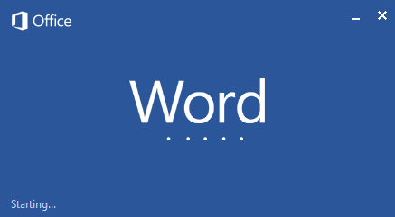

Follow these simple steps to open MS Word on your personal computer:
Start → All Programs → MS Office → MS Word.
Microsoft Word Interface
The Microsoft Word interface is designed for creating and editing documents.
File Menu: The File tab will bring you into the Backstage View. The Backstage View is where you manage your files and the data about them – creating, opening, printing, saving, inspecting for hidden metadata or personal information, and setting options.
Ribbon: An area across the top of the screen that makes almost all the capabilities of Word available in a single area.
Tabs: An area on the Ribbon that contains buttons that are organized in groups. The default tabs are Home, Insert, Design, Layout, References, Mailings, Review, View and EndNote X5.
Title Bar: A horizontal bar at the top of an active document. This bar displays the name of the document and application. At the right end of the Title Bar is the Minimize, Maximize and Close buttons.
Groups: A group of buttons on a tab that are exposed and easily accessible.
Dialog Box Launcher: A button in the corner of a group that launches a dialog box containing all the options within that group.
Status Bar: A horizontal bar at the bottom of an active window that gives details about the document.
View Toolbar: A toolbar that enables, adjusts, and displays different views of a document.
Zoom: Magnifies or reduces the contents in the document window.
Quick Access Toolbar: A customizable toolbar at the top of an active document. By default, the Quick Access Toolbar displays the Save, Undo, and Repeat buttons and is used for easy access to frequently used commands. To customize this toolbar, click on the dropdown arrow and select the commands you want to add.
Tell Me: This is a text field where you can enter words and phrases about what you want to do next and quickly get to features you want to use or actions you want to perform. You can also use Tell Me to find help about what you're looking for, or to use Smart Lookup to research or define the term you entered.
Contextual Tabs are designed to appear on the Ribbon when certain objects or commands are selected. These tabs provide easy access to options specific to the selected object or command. For example, the commands for editing a picture will not be available until the picture is selected, at which time the Picture Tools tab will appear. I will discuss it the later part in Drawing Tools and Picture Tools .
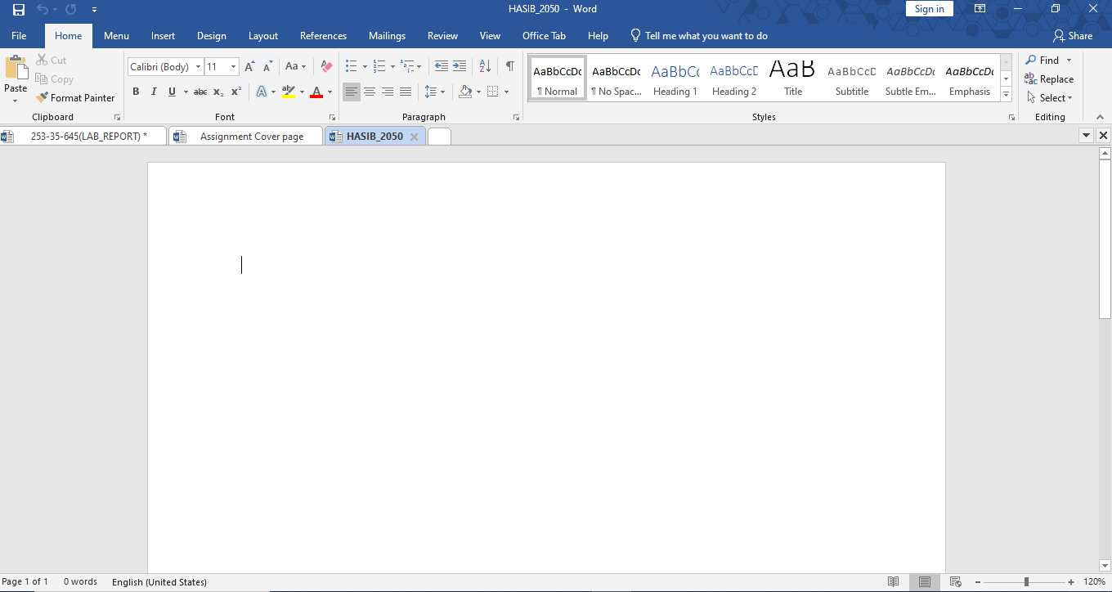
Menu Bar
Quick Access
Title
Status Bar
View Option
Cursor
Document Area

Microsoft Word Tabs Explained
Now let us discuss the tabs and components of MS Word. With these tabs, you can perform different operations on your documents. You can create, delete, style, modify, or view the content of your document.
1.FILE
It includes options related to the file, such as New (to create a new document), Open (to open an existing document), Save (to save the document), Save As (to save documents), History, Print, Share, Export, and Info.
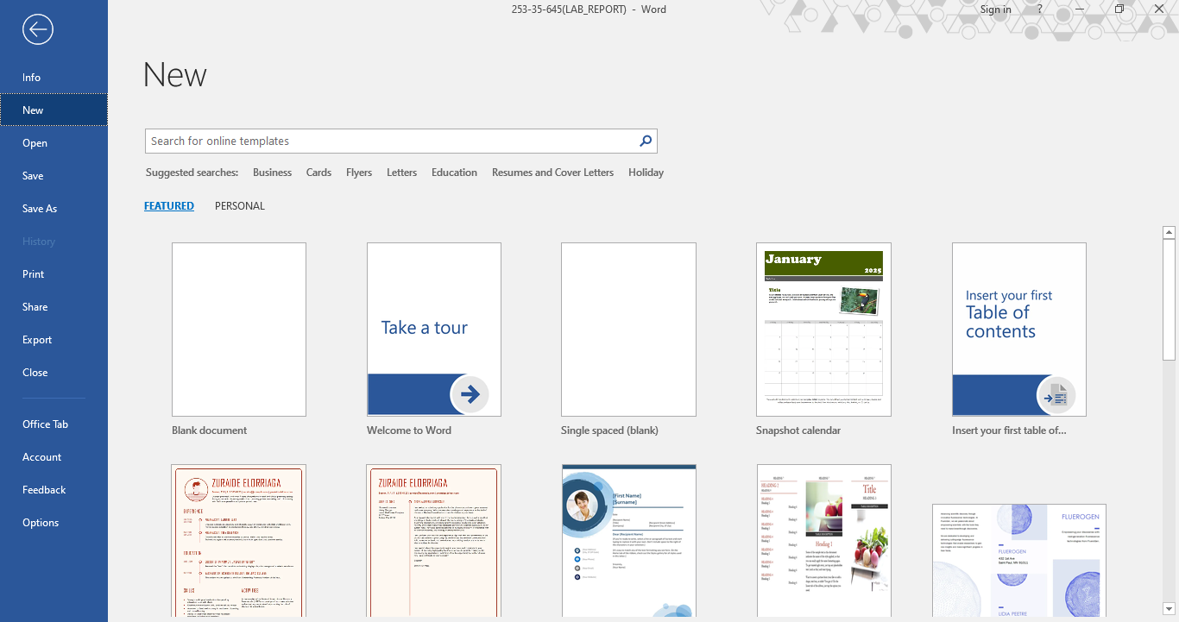
Search Bar

Templete Thumbnail

2. Home
It is the default tab of MS Word and it is generally divided into five groups, i.e., Clipboard, Font, Paragraph, Style and Editing. It allows you to select the color, font, emphasis, bullets, position of your text. It also contains options like cut, copy, and paste. After selecting the home tab, you will get below options:
- Font
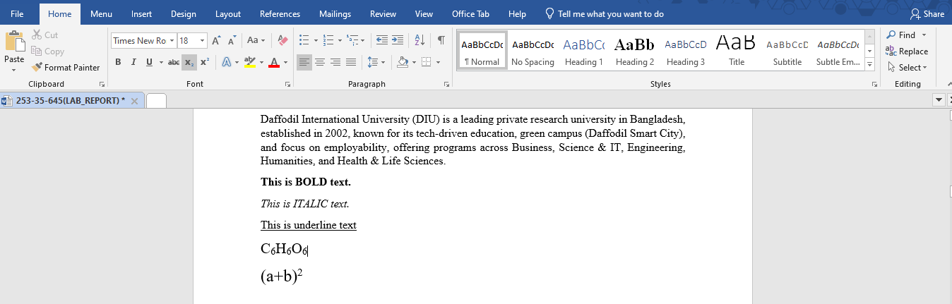
Font Dropdown Menu
Font size Dropdown Menu

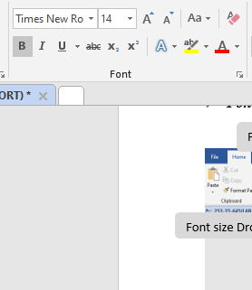
Italic Button
Underline Button
Subscript Button
Superscript Button
Bold Button
Press Ctrl+B to bold selected text.
Press Ctrl+I to italicize selected text.
Press Ctrl+U to underline selected text.
Press Ctrl+= to make selected text subscript. Press Ctrl+Shift++ to make selected text superscript.

3. Insert
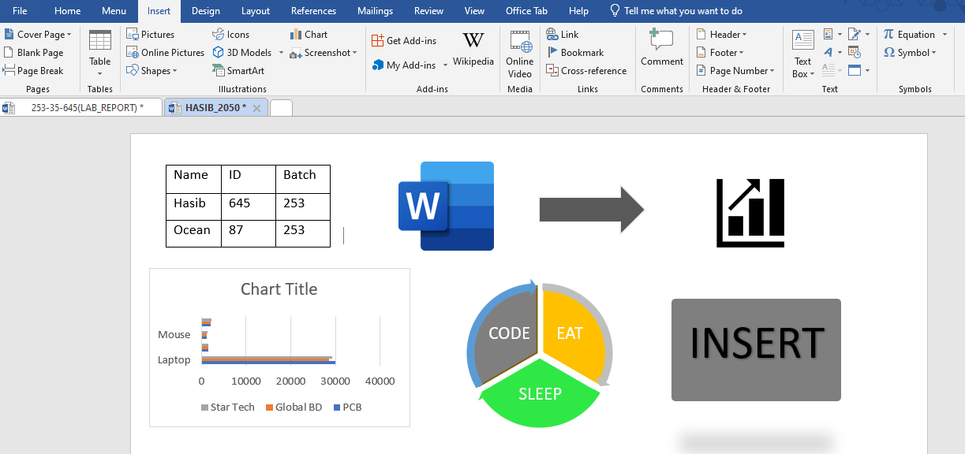
Add content like tables, images, hyperlinks, charts, word art, date and time, headers, footers, shapes, text boxes, equations, and more to your document.
Insert Table
Word Art
Smart Art
Picture
Icon
Shape
Chart

4. Design
It is the fourth tab in the ribbon or menu bar. You can choose from a variety of document designs on the design tab, including ones with centered titles, offset headings, left-justified text, page borders, watermarks, page color, and more, as seen in the image below:

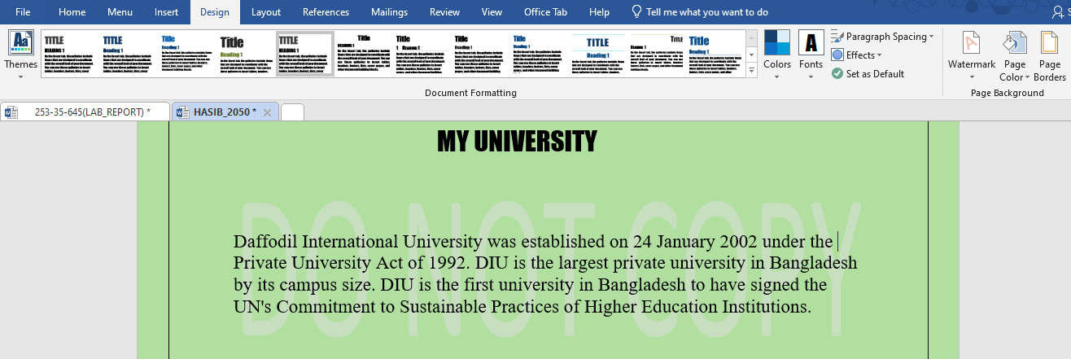

5.Layout
On the menu bar or ribbon, it is the fifth tab. It contains all the settings that let you customize the layout of the pages in your Microsoft Word document. As seen in the image below, it has features like line breaks, control page orientation and size, set margins, display line numbers, set paragraph indentation, and lines apply themes:
- Page orientation:
Word offers two page orientation options: landscape and portrait. Landscape means the page is oriented horizontally. Portrait means the page is oriented vertically.
To change page orientation :
- Select the Layout tab.
- Click the Orientation command in the Page Setup group.
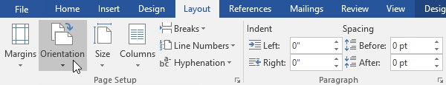

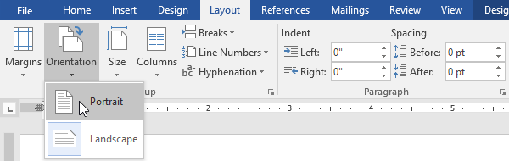
3. A drop-down menu will appear. Click either Portrait or Landscape to change the page orientation.

- The page orientation of the document will be changed.
- Page size
By default, the page size of a new document is 8.5 inches by 11 inches. Depending on your project, you may need to adjust your document's page size. It's important to note that before modifying the default page size, you should check to see which page sizes your printer can accommodate.
To change the page size:
Word has a variety of predefined page sizes to choose from.
- Select the Layout tab, then click the Size command.
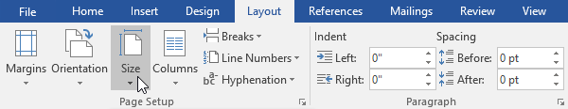
- A drop-down menu will appear. The current page size is highlighted. Click the desired predefined page size.

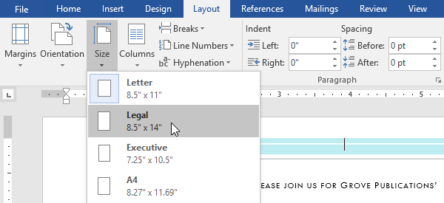

- The page size of the document will be changed.
- Page margins
A margin is the space between the text and the edge of your document. By default, a new document's margins are set to Normal, which means it has a one-inch space between the text and each edge. Depending on your needs, Word allows you to change your document's margin size.
To format page margins:
Word has a variety of predefined margin sizes to choose from.
- Select the Layout tab, then click the Margins command.
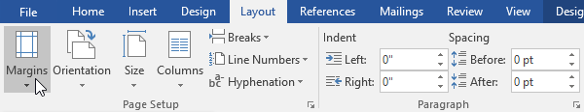

- A drop-down menu will appear. Click the predefined margin size you want.
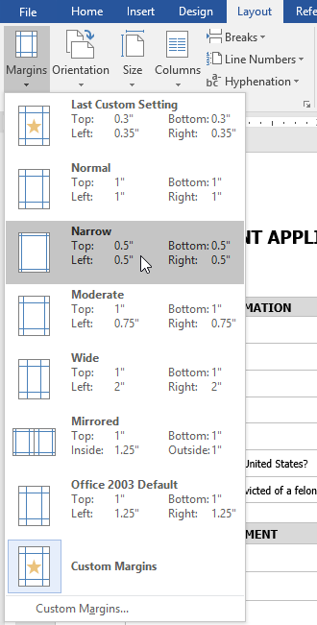
- Last Custom Setting – Shows the most recent margin values that the user manually set.
- Normal – Sets standard margins (1 inch on all sides). Used for most documents.
- Narrow – Reduces margins (0.5 inch on all sides) to fit more content on a page.
- Moderate – Uses slightly smaller side margins than Normal for a balanced layout.
- Wide – Increases left and right margins, often used for comments or binding.
- Mirrored – Sets inside and outside margins for double-sided printing (books or reports).
- Office 2003 Default – Applies the margin settings used in older versions of Word.
- Custom Margins – Opens a dialog box where users can set exact margin values manually.

- The margins of the document will be changed.

6. References
It is the sixth tab present in the menu bar or ribbon. The references tab lets you add references to a document, then create a bibliography at the end of the text. The references are generally stored in a master list, which is used to add references to further documents. It includes options like, Table of Contents, Footnotes, Citations & Bibliography, Captions, Index, Table of Authorities, smart look, etc. After selecting References tab, you will get the below options:
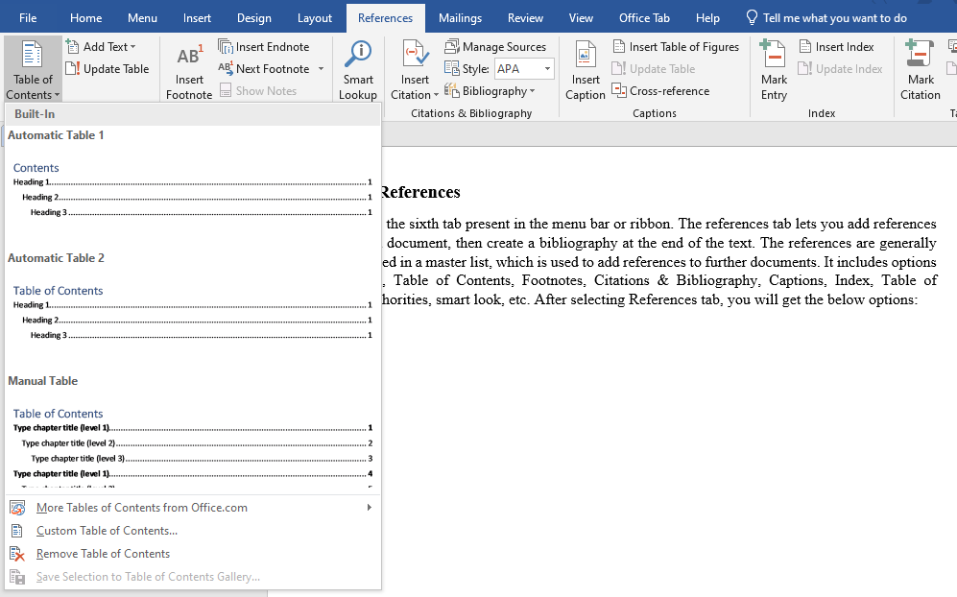

7. Mailings
It is the seventh tab present in the menu bar or ribbon. It is a least used tab in the menu bar. This tab is where you would create labels, print them on envelopes, do mail merge, etc. After selecting mailing, you will get the below options:
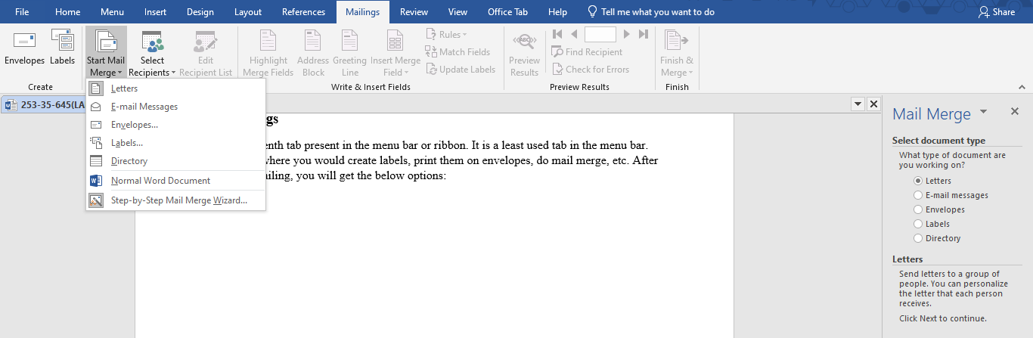

8. Review
It is the eighth tab present in the menu bar or ribbon. The review tab contains, commenting, language, translation, spell check, word count tools. It is good for quickly locating and editing comments. After selecting a review tab, you will get the options below:
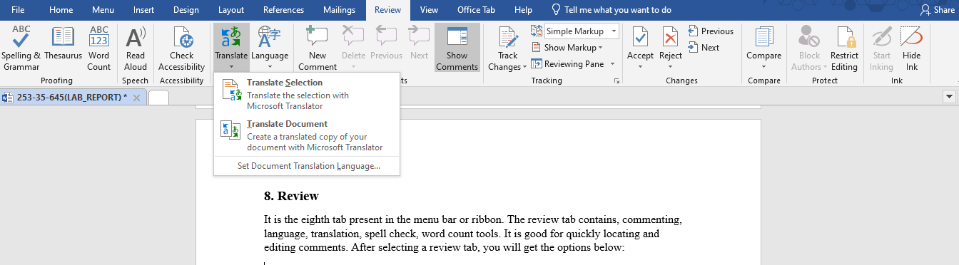
10. View
It is the ninth tab present in the menu bar or ribbon. View tab allows you to switch between single page or double page and also allows you to control the layout tools It includes print layout, outline, web layout, task pane, toolbars, ruler, header and footer, footnotes, full-screen view, zoom, etc. as shown in the below image:
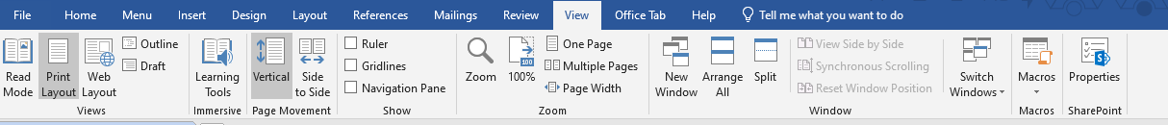
11. Formatting Tools for Pictures and Drawings in Microsoft Word
Microsoft Word provides a powerful set of formatting tools for pictures and drawings that help users enhance the visual appearance of documents. These tools allow users to adjust image quality, apply styles and effects, control text wrapping, and properly align visual elements with text. By using picture and drawing format options, documents become more attractive, clear, and professionally organized. These features are especially useful for creating assignments, reports, posters, and presentations where visual content plays an important role.
- Format Tools for Pictures
The Picture Format Tab in Microsoft Word appears automatically when a picture is selected. It contains a variety of tools that allow users to modify, enhance, and arrange images within a document. Using these tools, users can adjust image appearance, apply styles and effects, control how text wraps around pictures, and resize or crop images. The Picture Format Tab helps make documents more visually appealing, clear, and professionally presented.
- Adjust Group
- Remove Background – Removes unwanted background areas from an image.
- Corrections – Adjusts brightness, contrast, and sharpness.
- Color – Changes image color tone, saturation, or converts to grayscale.
- Artistic Effects – Applies visual effects like blur, sketch, or paint style.
- Transparency – Makes the picture partially transparent.

- Picture Styles Group
- Picture Styles – Applies pre-designed frames, borders, and shadows.
- Picture Border – Changes border color, thickness, and style.
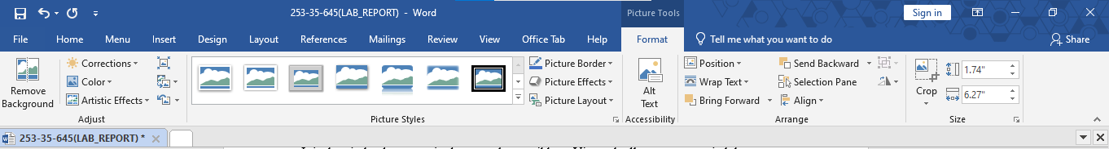
- Picture Effects – Adds effects such as shadow, reflection, glow, and 3D rotation.

- Arrange Group
- Position – Places the picture at a fixed location on the page.
- Wrap Text – Controls how text flows around the picture (Square, Tight, Behind Text, etc.).
- Bring Forward / Send Backward – Changes the layer order of images.
- Align – Aligns pictures with margins or other objects.
- Group / Ungroup – Combines multiple objects into one.
- Rotate – Rotates or flips the picture.
- Size Group
- Height & Width – Resizes the picture precisely.
- Crop – Removes unwanted parts of the image.
- Aspect Ratio Lock – Keeps image proportion while resizing.

- Format Tools for Drawings / Shapes
- Insert Shapes
- Edit Shape – Changes the shape type or edits its points.
- Add Text – Inserts text inside the shape.
- Shape Styles Group
- Shape Fill – Fills the shape with color, gradient, picture, or texture.
- Shape Outline – Changes border color, weight, and line style.
- Shape Effects – Adds shadow, glow, reflection, bevel, and 3D effects.

- WordArt Styles
- Text Fill – Changes text color inside the shape.
- Text Outline – Adds or edits text borders.
- Text Effects – Applies effects like shadow, glow, and transform.

- Arrange Group
- Position, Wrap Text, Align, Group, Rotate tools work similarly for drawings.

- Size Group
- Adjusts height, width, and scaling of shapes.

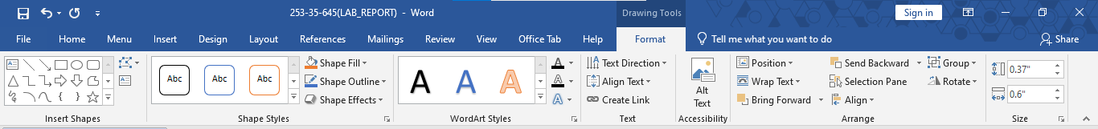
12. Conclusion
In conclusion, this lab report provided a detailed overview of the major tools and features of Microsoft Word along with their visual representations. Through this practical exploration, we gained a clear understanding of how different components such as menus, ribbons, and formatting tools work together to create, edit, and manage documents efficiently. This lab enhanced our practical skills and improved our confidence in using Microsoft Word for academic and professional purposes. Overall, the knowledge gained from this lab will be helpful for preparing well-structured documents in future tasks.

